N n. Personality Style
1. Total Never Rarely Sometime Often Always
I am assertive, ambitious, and self-motivated. 1 2 3 4 5
I enjoy taking risks and “change.” 1 2 3 4 5
I thrive in a challenge-based environment. 1 2 3 4 5
I think about the task more than others & myself. 1 2 3 4 5
I am motivated by accomplishment. 1 2 3 4 5

2. Total Never Rarely Sometime Often Always
I enjoy being with people. I am a “people” person. 1 2 3 4 5
I am optimistic and enthusiastic about people. 1 2 3 4 5
I like engaging people. “The more the merrier.” 1 2 3 4 5
I like “team” rather than being solo. 1 2 3 4 5
I am motivated by recognition and approval. 1 2 3 4 5

3. Total Never Rarely Sometime Often Always
I tend to be sensitive toward others and diplomatic. 1 2 3 4 5
I tend to be low risk and lean into security. 1 2 3 4 5
I enjoy people in a small group setting. 1 2 3 4 5
I thrive in consistent environments. 1 2 3 4 5
I am motivated by stability and support. 1 2 3 4 5

4. Total Never Rarely Sometime Often Always
I don’t need people to thrive. 1 2 3 4 5
I am good at details and tasks. 1 2 3 4 5
I like to do things right the first time. 1 2 3 4 5
I comply with clearly defined rules. 1 2 3 4 5
I am motivated by quality and correctness. 1 2 3 4 5

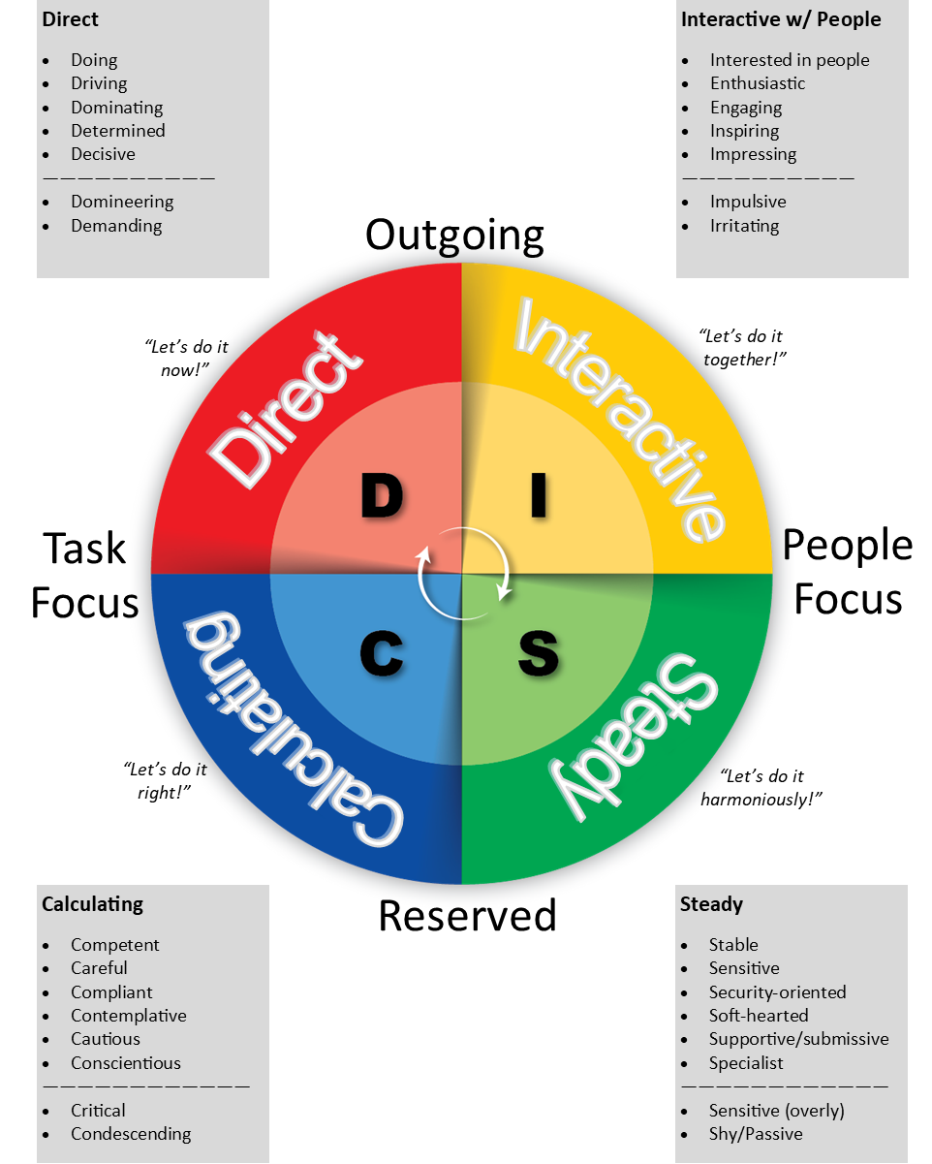

I
D

S
C

“I praise You because I am fearfully and wonderfully made; Your works are wonderful, I know that full well.” PSALM 139:14

Please take some time to read about your personality type and the strengths and weaknesses that may come naturally to you.

D We are direct and decisive. We are risk takers and problem solvers.
We are more concerned with completing tasks and winning than
we are with gaining approval from people. Though the internal drive
tends to make us insensitive to those around us, “D”s are not afraid
to challenge the status quo, and we thrive when it comes to devel-
oping new things. We need discipline to excel, and respond to direct
confrontation. Our greatest fear is to be taken advantage of, and
even despite our possible weaknesses—which include an aversion to
routine, a tendency to overstep authority, an argumentative nature,
and a habit of taking on too much—we place a high value on time
and use our innovative thinking to accomplish difficult tasks and
conquer challenges.

D/I We are curious concluders who place emphasis on the bottom line
and work hard to reach our goals. We are more determined than
we are inspirational, yet our high expectations and standards for
ourselves and those around us typically cause us to make quite an
impact, motivating others to follow us. We have an array of interests
and can become distracted by taking on too many projects. We often
need to focus, prioritize, and simply slow down. Because we thrive on
activity and forward motion, we like to accomplish tasks through a
large number of people.
Joshua (Joshua 1), Noah (Genesis 6-9), Sarah (Genesis 16, 1 Peter 3:6)

D/S We are achievers with an ability to persevere. We are more active
than passive, but possess a kind of calm sensitivity and steadiness
that makes us good leaders. We seem to be people-oriented but can
easily be dominant and decisive when it comes to tasks and project
planning. We strive to accomplish goals with fierce determination
that comes from strong internal drive, but we could benefit from
contemplative and conservative thinking as well as spending more
time focusing on relationships.
Daniel (Daniel 1-6), Job (Job 1:5, James 5:11), Martha (Luke 10:38-42)

D/C We are challengers that can either be determined students or defiant
critics. Being in charge is important to us, yet we care little about
what others think as long as we get the job done. We have a great
deal of foresight and examine every avenue to find the best solution.
We prefer to work alone. Though we fear failure and the lack of
influence, we are motivated by challenges and can often be excellent
administrators. We can benefit from learning to relax and paying
more attention to people.
Malachi (Malachi 4), Nathan (2 Samuel 12:1-13), Nahum (Nahum 1-3)

I We are inspiring and impressive. Enthusiastic, optimistic, impulsive,
and emotional—we tend to be creative problem solvers and excellent
encouragers. We often have a large number of friends, but we can
become more concerned with approval and popularity than
with getting results. Our greatest fear is rejection, but we thrive when
it comes to motivating others. Our positive sense of humor helps us
negotiate conflicts. Though we can be inattentive to details and
poor listeners, we can be great peacemakers and effective
teammates when we control our feelings and minimize our urge to
entertain and be the center of attention. We value lots of human
touch and connection.

I/D We are persuaders who are outgoing and energetic. We enjoy large
groups and use our power of influence to attain respect and convince
people to follow our lead. Sometimes we can be viewed as fidgety
and nervous, but it comes from our need to be a part of challenges
that have variety, freedom, and mobility. We could benefit from
learning to look before we leap and spending more time being
studious and still. We make inspiring leaders and know how to get
results from and through people.
John the Baptist (Luke 3), Peter (Matthew 16 and 26, Acts 3), Rebekah (Genesis 24)

I/S We are influential counselors who love people, and it’s no surprise
that people love us. We live to please and serve, and tend to be good
listeners. Looking good and encouraging others is important to us,
as is following through and being obedient. We often lack in the area
of organization and can be more concerned with the people involved
than we are with the task at hand. However, we can be center stage
or behind the scenes with equal effectiveness, and we shine when it
comes to influencing and helping others.
Barnabas (Acts 4, 9, 11-15), Elisha (1 Kings 19, 2 Kings 2-3), Nicodemus (John 3, 7, 19)

I/C We are inspiring yet cautious assessors who are excellent
communicators through the combination of concerned awareness
and appreciation of people. We excel in determining ways to improve
production. We tend to be impatient and critical, and can also be
overly persuasive and too consumed by the desire to win. We like to
work inside the box, and we could benefit from trying new things and
caring less about what others think. This personality type often
possesses a gift for teaching; we are generally dependable when it
comes to paying attention to details and getting the job done.
Miriam (Exodus 15-21), Ezra (Ezra 7-8), Shunammite Woman (2 Kings 4:8-37)

S We are steady and more reserved. We do not like change, and thrive
in secure, non-threatening environments. We are often friendly and
understanding as well as good listeners and loyal workers who are
happy doing the same job consistently. With an incredible ability to
forgive, reliable and dependable “S”s tend to make the best friends.
Our greatest fear, however, is loss of security, and our possible
weaknesses naturally include not only resistance to change, but also
difficulty adjusting to it. We can also be too sensitive to criticism and
unable to establish priorities. In order to avoid being taken advantage
of, we need to be stronger and learn how to say “no.” We also like to
avoid the limelight, but when given an opportunity to genuinely help
others, we will gladly rise to the occasion. We feel most valued when
we have truly helped someone.

S/D We are quiet leaders who can be counted on to get the job done. We
perform better in small groups and do not enjoy speaking in front of
crowds. Though we can be soft- and hard-hearted at the same time,
we enjoy close relationships with people, being careful not to
dominate them. Challenges motivate us, especially ones that allow
them to take a systematic approach. We tend to be determined,
persevering through time and struggles. We benefit from
encouragement and positive relationships.
Martha (Luke 10:38-42), Job (Job 1:5, James 5:11)

S/I We are inspirational counselors who exhibit warmth and sensitivity.
Tolerant and forgiving, we have many friends because they accept
and represent others well. Our social nature and desire to be likable
and flexible makes us inclined to be overly tolerant and non-confron-
tational. We will benefit from being more task-oriented and paying
more attention to detail. Kind and considerate, we include others and
inspire people to follow us. Words of affirmation go a long way with
us, and with the right motivation, we can be excellent team players.
Mary Magdalene (Luke 7:36-47), Barnabas (Acts 4, 9, 11-15), Elisha (1 Kings 19,
2 Kings 2-13)

S/C We are diplomatic and steady, as well as detail-oriented. Stable and
contemplative, we like to weigh the evidence and discover the facts
to come to a logical conclusion. More deliberate, we prefer to take
our time, especially when the decision involves others. Possible
weaknesses include being highly sensitive and unable to handle
criticism, and we also need to be aware of the way we treat others.
Operating best in precise and cause-worthy projects, we can be a
peacemaker; this makes us a loyal team member and friend.
Moses (Exodus 3, 4, 20, 32), John (John 19:26-27), Eliezer (Genesis 24)

C We are compliant and analytical. Careful and logical lines of thinking
drive us forward, and accuracy is a top priority. We hold high
standards and value systematic approaches to problem solving.
Though we thrive when given opportunities to find solutions, we tend
to ignore the feelings of others and can often be critical and down-
right crabby. Verbalizing feelings is difficult for us, but when we are
not bogged down in details and have clear-cut boundaries, we can
be big assets to the team by providing calculated “reality checks.”
Our biggest fear is criticism, and our need for perfection is often
a weakness, as is our tendency to give in when in the midst of an
argument. However, we are thorough in all activities and can bring a
conscientious, even-tempered element to the team that will provide
solid grounding. We value being correct

C/I We are attentive to the details. We tend to impress others by doing
things right and stabilizing situations. Not considered aggressive or
pushy, we enjoy both large and small crowds. Though we work well
with people, we are sometimes too sensitive to what others think
about us and our work. We could benefit from being more assertive
and self-motivated. Often excellent judges of character, we easily
trust those who meet our standards. We are moved by genuine and
enthusiastic approval as well as concise and logical explanations.
Miriam (Exodus 15-21, Numbers 12:1-15), Ezra (Ezra 7, 8)

C/S We are systematic and stable. We tend to do one thing at a time—
and do it right. Reserved and cautious, we would rather work behind
the scenes to stay on track; however, we seldom take risks or try new
things and naturally dislike sudden changes in our environments.
Precisionists to the letter, we painstakingly require accuracy and fear
criticism, which we equate to failure. Diligent workers, our motivation
comes from serving others.
Esther (Esther 4), Zechariah (Luke 1), Joseph (Matthew 1:1-23)

C/D We are cautious and determined designers who are consistently
task-oriented and very aware of problems. Sometimes viewed as
insensitive, we do care about individual people but have a difficult
time showing it. We often feel we are the only ones who can do the
job the way it needs to be done, but because of our administrative
skills, we are able to bring plans for change and improvements to
fruition. We have a tendency to be serious and could benefit from
being more optimistic and enthusiastic. Despite our natural drive to
achieve, we should concentrate on developing healthy relationships
and simply loving people.
Bezalel (Exodus 35:30-36, 8, 37:1-9), Jochebed (Exodus 1:22-2:4), Jethro (Exodus 2,18)

MAKING THE MOST OF YOUR PERSONALITY

“For we are His workmanship, created in Christ Jesus for good works.” EPHESIANS 2:10 NASB

Every personality has strengths and challenges. The following will give you specific areas to focus on to help you work well with others.

HOW TO HANDLE CONFLICTS

Often, the greatest hindrances to healthy relationships are personality conflicts. Positive individuals, desiring to build good relationships, are often discouraged because of misunderstandings and clashes with others. This section is designed to help you discover why people do what they do under pressure and why you may conflict with others. Life’s success principles on how to handle clashes are clear. The problem is many people are not aware of their “sensitive spots”. Everyone needs to learn more about avoiding and resolving conflicts.

Every personality has its “hot button”. Everyone can act like a “D” when pushed too far. The following are

tendencies of personalities as they relate under pressure.
Review the following pages with your Behavioral Blends in mind. Read each section to see how you may respond as a specific personality type. Also consider how you may respond differently because of your “hot and cold buttons”.

To improve your effectiveness, control your personality and never use it as an excuse for poor behavior.

Remember:
Most problems today are not theological –
they’re relational – personality conflicts and clashes with others.
“D” Behavior and all Spiritual Gifts  Under Pressure:  Becomes dictatorial, domineering, demanding, angry, intense, forceful, direct, bossy.  Sources of Irritation:  Weakness, indecisiveness, laziness, lack of discipline, plan, purpose, direction, authority, control, challenge.  Needs To:  Back off, seek peace, relax, think before reacting, control self, be patient, loving, friendly, loyal, kind, sensitive. | “I’ Behavior and all Spiritual Gifts  Under Pressure:  Becomes hyper, overly optimistic, immature, emotional, irrational, silly, wordy, selfish.  Sources of Irritation:  Disinterest, slowness, pessimism, details, time restraints, antagonism, doubt, structure, lack of enthusiasm, team participation.  Needs To:  Listen, count the cost, control emotions, be humble, strong, disciplined, punctual, careful with words, conscientious.
“C” Behavior and all Spiritual Gifts  Under Pressure:  Becomes moody, critical, contemplative, negative, worrisome.  Sources of Irritation:  Incompetence, disorganization, foolishness, dishonesty, inaccuracy, wastefulness, inconsistency, blind faith, false impressions.  Needs To:  Loosen up, communicate, be joyful, positive, tolerant, compromising, open, trusting, enthusiastic. | “S” Behavior and all Spiritual Gifts  Under Pressure:  Becomes subservient, insecure, fearful, weak-willed, withdrawn, sympathizer, sucker.  Sources of Irritation:  Pushiness, instability, inflexibility, anger, disloyalty, insensitivity, pride, discrimination, unfairness.  Needs To:  Be strong, courageous, challenging, aggressive, assertive, confrontational, enthusiastic, outgoing, expressive, cautious, bold.
Natural Responses to Conflict-  “D” – Want to Attack  “I” – Want to Expose Others  “S” – Want to Support or Submit  “C” – Want to Criticize | Recommended Wise Responses-  “D” – Restore with Love  “I” – Make others look good  “S” – Care Enough to Confront  “C” – Examine Own Self First

COUNTERACTING NEGATIVE TENDENCIES
To improve your effectiveness, control your personality and never use it as an excuse for poor behavior.

“D” personalities are dominant, direct, task-oriented, decisive,
organized, outgoing, and outspoken. As you embrace these strengths,
also make sure to:
• Listen attentively to others and support other team members.
• Invest in personal relationships.
• Balance controlling and domineering tendencies.
• Value the opinions, feelings, and desires of others.

“I” personalities are influential, witty, easygoing, outgoing, and people oriented.
As you embrace these strengths, also make sure to:
• Be aware of tasks that need to be accomplished.
• Balance your emotions, words, and actions.
• Remember to consider details and facts.
• Slow down your pace for others when necessary.
• Listen attentively to others instead of only talking.
• Choose thoughtful decision-making over impulsive decision-making.

“S” personalities are steady, stable, analytical, introverted, and people oriented.
As you embrace these strengths, also make sure to:
• Take initiative.
• Practice flexibility.
• Approach confrontation constructively.
• Be direct in your interactions when necessary.
• Realize change can be healthy and be willing to adapt.
• Consider the overall goals of your family or group, not just specific
processes or procedures.

“C” personalities are compliant, competent, task-oriented, goal-oriented,
and introverted. As you embrace these strengths, also make sure to:
• Be decisive when necessary.
• Cultivate personal relationships.
• Be open to others’ ideas and methods.
• Balance your focus between facts and people.
• Focus on doing the right things, not just doing things right.
• Help others accomplish their goals.

